**identification AND prediction OF heart disease USING DEEP LEARNING ON NEURAL NETWORKS**

ANUSHA NAGULAPATI- 700748216

PRIYANKA CHOWDARY PINNAMANENI - 700744635

MANASWINI BABERS- 700745092

PRAVEEN THATIKANTI- 700757678

**Proposal**

Heart-related diseases are among the most widely recognized reasons for death around the world. Patients are frequently asymptomatic until a deadly occasion occurs, and in any event, when they are under perception, a prepared workforce is required to recognize a heart abnormality. Somewhat recently, there has been expanding proof of how deep learning can be utilized to recognize such oddities, because of the accessibility of Electrocardiograms (ECG) in computerized design. New advancements in innovation have permitted us to take advantage of such information to fabricate models ready to dissect the examples in the event of heartbeats, and spot abnormalities from them. In this work, master cardiologists across various clinics and nations can recognize 7 sorts of signs: Typical, AF, Tachycardia, Bradycardia, Arrhythmia, Other, or Boisterous. [1][2]

Determining heart illness has become a troublesome clinical errand in the current clinical examination. This finding relies upon the point-by-point and exact examination of the patient's clinical test information on a singular's well-being history. The huge improvements in the field of profound learning look to make astute mechanized frameworks that help specialists anticipate and decide the illness with the web of things with Deep learning. Certainty adjustment is an especially important issue in a medical care setting like the one tended to in this composition: when a neural network model makes an expectation, it is vital that this result can be relied upon.[3]

The Deep learning algorithm will be applied in the prediction of heart disease with a different type of attributes with the dataset.

**Objective:**

The objective of heart disease identification with deep learning is to detect heart disease in the early stage itself with the available attributes. In this work, the dataset containing heart disease will be taken into consideration[1][6]. The pre-processing will be applied to the dataset, and the noisy and null value data will be removed. After the data will be analyzed and visualized for further processing. The Deep learning algorithm will be chosen to make the prediction.

The dataset will be divided into two parts. The first part of the dataset is 70% taken to provide training to the Deep learning algorithm and the remaining 30% of data is taken to the testing part.

**Motivation :**

Deep learning will be the Python-based application that contributes to finding out the heart disease’s early stage. It will be helpful for humans to detect it early and to take the necessary treatments at the correct time.

**Significance:**

The project evaluation can be tested with the deep learning algorithm prediction results. Since the Deep learning algorithm will be used to predict the disease, the accuracy of the algorithm result will be helpful to evaluate the results. [4]The accuracy score of the algorithm in heart disease identification helps to evaluate the dataset.

The application will be developed with Google Colab Python Tool as the project can be directly executed in any type of computer system with an internet connection. There is no need for any specific software to be installed in the user system. The Colab Tool helps to develop and run the application directly inside the cloud server where the Python library files are installed. The deep learning algorithm libraries are built inside the Colab. It helps the project to use the deep learning algorithm in the finding of heart disease.

**INCREMENT**

**Techniques Applied:**

The task included the examination of the heart disease patient dataset with appropriate information handling. Then, at that point, various models were prepared and expectations are made with the Deep Learning model.[1][7] The machine learning library and deep learning libraries Sklearn and Keras are applied to the application.

**Dataset:**

Most of the columns in a dataset are noisy and contain lots of information. But with feature engineering, will get more good results. The first step is to import the libraries and load data. After that will take a basic understanding of data like its shape, sample, is there any NULL values present in the dataset. Understanding the data is an important step for prediction or any Deep learning project. It is good that there are no NULL values.

The dataset heart.csv is downloaded from the Kaggle website, it has 300 rows and 14 columns present.

**Detailed Design of Features:**

This dataset contains the fields needed for the analysis of the heart disease dataset. The exploratory examination is a cycle to investigate and comprehend the information and information related in a total profundity with the goal that it makes highlight designing and Deep Learning demonstrating steps smoothly and smoothed out for expectation. The exploratory examination assists with validating our presumptions or misleading.

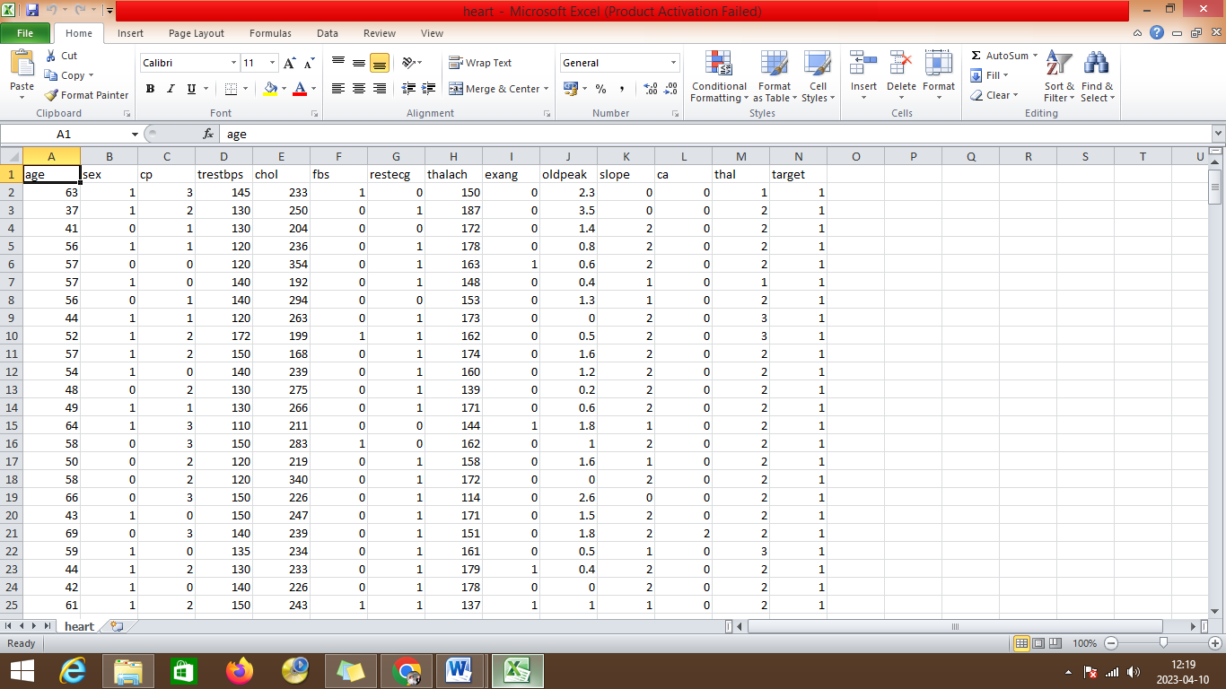

**Analysis of Heart Disease Prediction:**

It will begin from the principal segment and investigate every section and comprehend what influence it makes on the objective segment. At the necessary step, we will likewise perform preprocessing and include design undertakings. The point in acting top-to-bottom exploratory examination is to get ready and clean information for better Deep Learning demonstrating to accomplish elite execution and summed up models. So it should begin with breaking down and setting up the dataset for expectation.

**Modules:**

1) Dataset collection

2) Data cleaning

3) Data Analysis

4) Deep learning Modeling

5) Report

1) Dataset collection:

The information about the heart disease dataset with different types of attributes are collected from different type of patients.

2) Data Cleaning:

The large dataset contains more noisy and improper data which have to be pre-processed to produce a quality dataset for further pruning. The data is cleaned and processed with the initial stage of removing the null values.

3) Data Analysis

Exploratory analysis is a process to explore and understand the data and data relationship in complete depth so that it makes feature engineering and machine learning modeling steps smooth and streamlined for prediction. It helps to prove our assumptions true or false. In other words, it helps to perform hypothesis testing.

4) Deep learning Modeling

Deep learning modeling helps to find the best algorithm with the best hyperparameters to achieve maximum accuracy. The dataset is split into 2 variants. 70% of records are taken as training data and used to train the machine learning algorithm. The remaining 30% of the dataset is applied to testing which helps to predict the process.

5) Report:

The Data is visualized based on the output of the Deep Learning algorithm and the data is mapped with different types of graphs to analyze and visualize the exact data to the user for the prediction. Matplot libraries are implemented to map the results based on user requirements.

**SYSTEM SPECIFICATION**

**HARDWARE REQUIREMENTS**

* Processor Intel(R) Pentium(R) CPU G2010 @
* Clock Speed 2.80GHz
* RAM 2.00 GB
* Hard Disk 1 TB HDD
* Monitor 15.6 Inches
* Mouse Logitech B100 Wired Optical Mouse
* Keyboard Full-size island-style keyboard with number keypad
* Display Card Super Video Graphics Adapter

**SOFTWARE REQUIREMENTS**

* Operating System: Windows 10
* Front-End Tool: Python in Google Colab

**SYSTEM ARCHITECTURE DIAGRAM**

Heart Disease prediction

Training, test data

Data Cleaning

Data preprocess

Deep Learning Algorithm implementation

Heart diseaseDataset

ARCHITECTURE DIAGRAM

The heart disease dataset is given as input to the application and the pre-processing is applied, next the data cleaning is performed after the training and test data are splitted down and passed into the Deep Learning algorithm and the heart disease prediction is done.

**Load Packages:**

The first step is to import the necessary packages to the application:

//---AI Library files

from keras.models import Sequential

from keras.layers import Dense

import numpy as np

import pandas as pd

import matplotlib.pyplot as plt

import seaborn as sns

%matplotlib inline

import os

print(os.listdir())

import warnings

warnings.filterwarnings('ignore')

Next, the dataset would be connected from the Google Colab. Initially, the dataset is uploaded into the Google Colab folder. Then the Python file should connect to the path from the Google Colab folder.

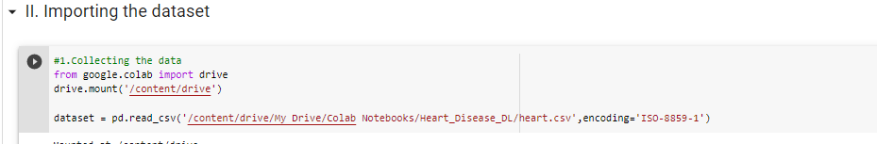

The information has an extremely straightforward design with elements. Each column is related to the heart disease attributes.

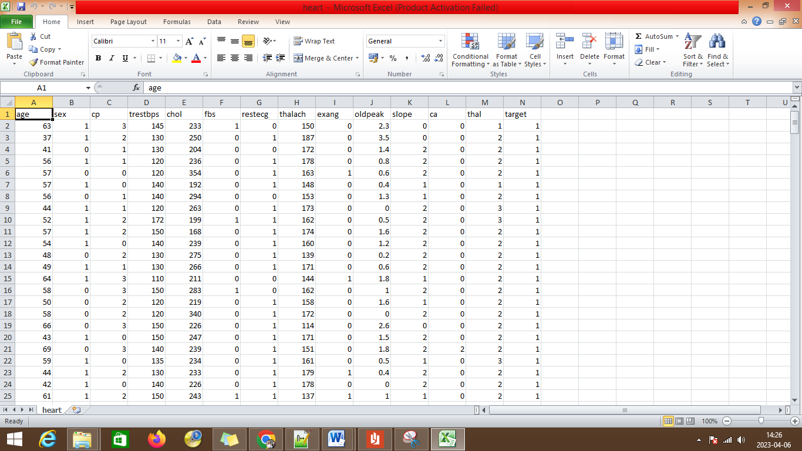

The label has been set with different label description features of:

* age
* sex
* cp
* trestbps
* cholestral
* fbs
* restecg
* oldpeak
* slope
* ca
* thal
* target

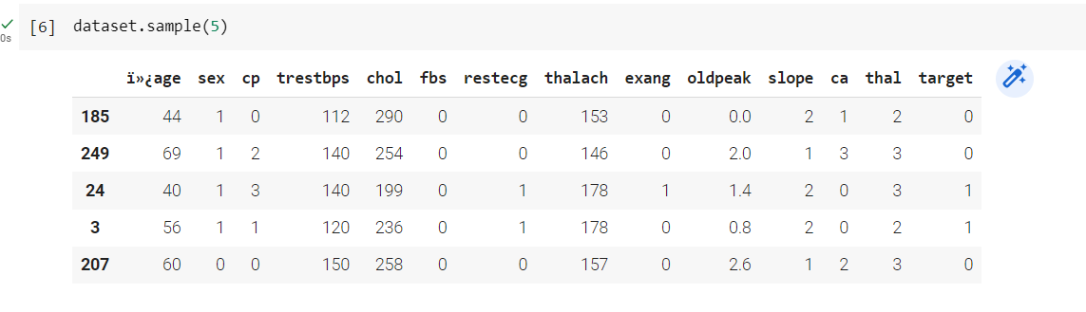

The dictionary shows the records displayed with head values of the first 5 records from the dataset. The bar plot can be used to address the heart disease attributes.

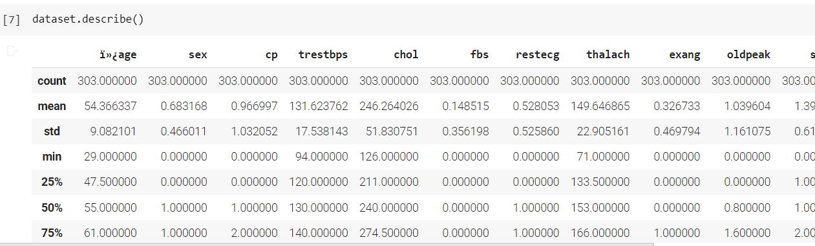

The describe function describes the count, mean, max, and min statistical reports for the columns of age, sex, cp, chol, and other fields.

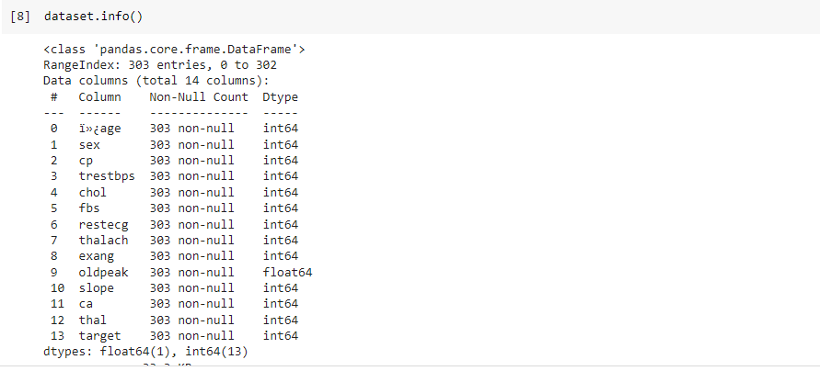

The information about the data is displayed with the data type.

**Attributes Exploration:**

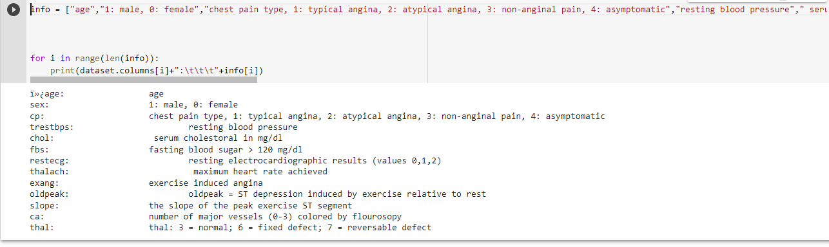

The heart disease dataset attributes are explored for further analysis.

Below are the values:

sex: 1: male, 0: female

cp: chest pain type, 1: typical angina, 2: atypical angina, 3: non-anginal pain, 4: asymptomatic

trestbps: resting blood pressure

chol: serum cholesterol in mg/dl

fbs: fasting blood sugar > 120 mg/dl

restecg: resting electrocardiographic results (values 0,1,2)

thalach: maximum heart rate achieved

exang: exercise-induced angina

oldpeak: oldpeak = ST depression induced by exercise relative to rest

slope: the slope of the peak exercise ST segment

ca: number of major vessels (0-3) colored by fluoroscopy

thal: thal: 3 = normal; 6 = fixed defect; 7 = reversible defect

**Analyzing:**

The target variables are analyzed

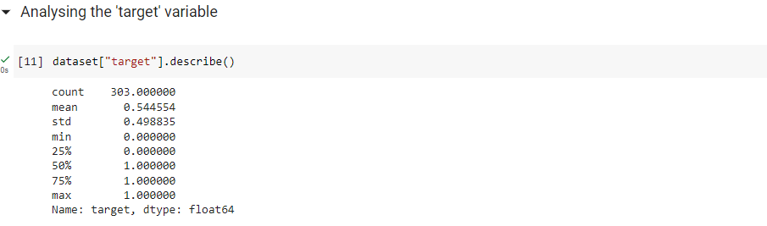

**Correlation of data:**

The correlation of data with respect to the attributes is linked and displayed.

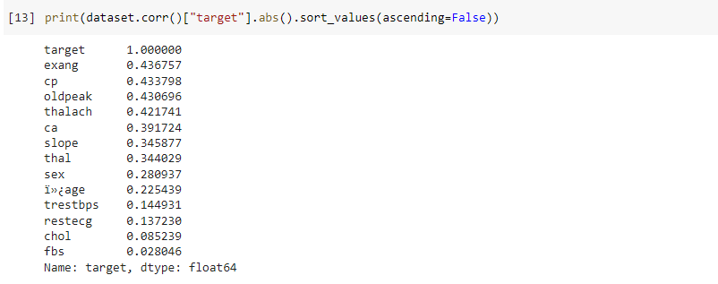

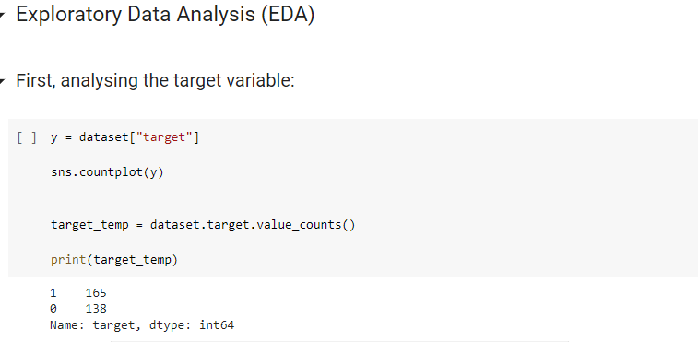

The target variable is assigned to the y variable.

**Implementation with Algorithms:**

The testing and training variables are split and passed into the algorithm for heart disease prediction.

**Keras model of Deep Learning:**

Keras is a brain network Application Programming Connection point for Python that is firmly coordinated with Tensor Stream, which is utilized to construct AI models. Keras models offer a straightforward, easy-to-understand method for characterizing a brain organization, which will then, at that point, be fabricated.

Keras is a strong and simple to-involve free open-source Python library for creating and assessing profound learning models. It is important for the Tensor Flow library and permits you to characterize and prepare brain network models in only a couple of lines of code.

Keras Deep Learning working process:

1. Dataset load
2. Keras Model Definition
3. Keras Model Compilation
4. Keras Model Fit and evaluation.
5. Predictions

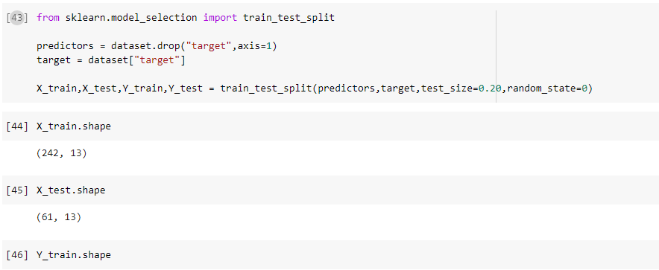

The testing size is 20% and the training size is 80% of the dataset.

**Evaluation with Neural Network of Deep Learning with Keras Model:**

The possibility of ANNs depends on the conviction that the working of the human cerebrum by making the right associations can be imitated involving silicon and wires as living neurons and dendrites.

The human cerebrum is made out of 80 billion nerve cells called neurons. They are associated with other thousand cells by Axons. Upgrades from outside climate or contributions from tangible organs are acknowledged by dendrites. These data sources make electric motivations, which rapidly travel through the brain organization. A neuron can then send the message to another neuron to deal with the issue or doesn't send it forward.

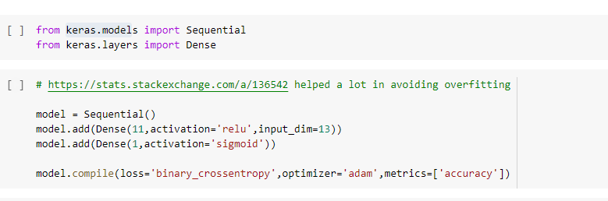

**Preliminary Results:**

The accuracy of the neural network is given below:

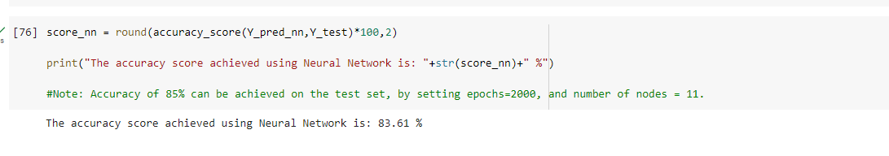

The final results are compared with different type of algorithm accuracy levels.

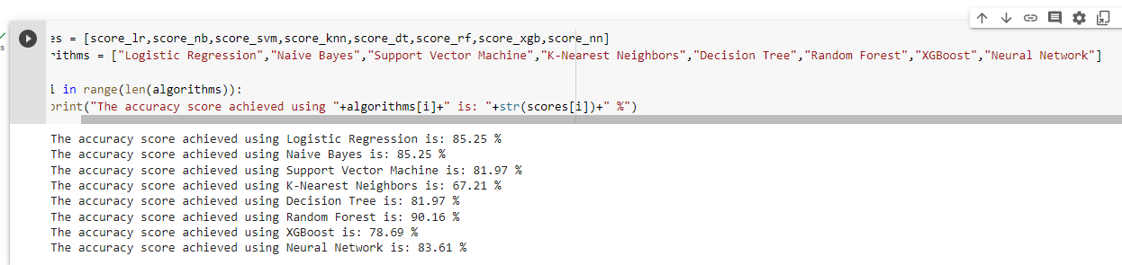

**Conclusion and Future Enhancement:**

The heart disease with a different types of algorithms is compared and the accuracy levels were identified and compared. The Deep learning algorithm provides better accuracy levels for the prediction. In the future, the large dataset can be used for the prediction which will help to increase the efficiency of the algorithm in predictions.

**Work completed:**

• Description

The heart disease dataset containing the information of the heart disease patient details report has been analyzed with Deep learning algorithms and the results are compared with the graphical reports.

• Responsibility and Contribution (Task, Person, Percentage)

Logistic Regression and Decision Tree – Manaswini Babers

Naive Bayes and XGBoost – Anusha Nagulapati

K-Nearest Neighbors and Random Forest – Priyanka Chowdary Pinnamaneni

Support Vector Machine and Neural Network – Praveen Thatikanti

• Issues/Concerns

Predicting the exact model based on the dataset is one of the major challenges in the findings and it can be improved by considering a large dataset.

**References/Bibliography:**

[1]. Samiul based shuvo 1, shams nafisa ali 1, (student member, ieee), soham irtiza swapnil1, mabrook s. al-rakhami 2, (senior member, ieee), and abdu gumaei “CardioXNet: A Novel Lightweight Deep Learning Framework for Cardiovascular Disease Classification Using Heart Sound Recordings”. February 24, 2021, date of publication March 2, 2021, date of current version March 9, 2021.IEEE.

[2]. Eun s. lee 1, (member, ieee), byeong g. choi 2, (member, ieee), myung y. kim1, (Member, IEEE), AND SEUNG H. HAN 3, (Member, IEEE)” An Imbalanced-DataProcessingAlgorithmforthe Prediction of Heart Attack in Stroke Patients”. January 14, 2021, date of publication February 8, 2021, date of current version February 16, 2021, IEEE.

[3]. Hao ren2,1∗ aslan b. wong1∗, wanmin lian3∗, weibin cheng2, ying zhang1, jianwei he1. “Interpretable Pneumonia Detection by Combining Deep Learning and Explainable Models with Multisource Data” 10.1109/ACCESS.2021.3090215, IEEE Access.

[4] G. Liang and L. Zheng, “A transfer learning method with deep residual network for pediatric pneumonia diagnosis,” Computer methods and programs in biomedicine, vol. 187, p. 104964, 2020

[5] D. Margaritis, “Learning bayesian network model structure from data,” 2003.

[6] X.-W. Chen, G. Anantha, and X. Lin, “Improving bayesian network structure learning with mutual information-based node ordering in the k2 algorithm,” IEEE Transactions on Knowledge and Data Engineering, vol. 20, no. 5, pp. 628–640, 2008.

[7] S. Watanabe, “A widely applicable bayesian information criterion,” Journal of Machine Learning Research, vol. 14, no. Mar, pp. 867–897, 2013.

[8] J. Yao, J. E. Burns, D. Forsberg, A. Seitel, A. Rasoulian, P. Abolmaesumi, K.Hammernik,M.Urschler,B.Ibragimov,R.Korezetal.,“Amulti-center milestonestudyofclinicalvertebralctsegmentation,”ComputerizedMedical Imaging and Graphics, vol. 49, pp. 16–28, 2016.

[9] H. R. Roth, L. Lu, A. Seff, K. M. Cherry, J. Hoffman, S. Wang, J. Liu, E. Turkbey, and R. M. Summers, “A new 2.5 d representation for lymph node detection using random sets of deep convolutional neural network observations,” in International conference on medical image computing and computer-assisted intervention. Springer, 2014, pp. 520–527.

[10] H. R. Roth, L. Lu, A. Farag, H.-C. Shin, J. Liu, E. B. Turkbey, and R.M.Summers,“Deeporgan:Multi-level deep convolutionaln etworksfor automatedpancreassegmentation,”inInternationalconferenceonmedical image computing and computer-assiste dintervention. Springer,2015,pp. 556–564.

[11] L. Yao, E. Poblenz, D. Dagunts, B. Covington, D. Bernard, and K.Lyman,“Learningtodiagnosefromscratchbyexploitingdependencies among labels,” CoRR, vol. abs/1710.10501, 2017. [Online]. Available: <http://arxiv.org/abs/1710.10501>

[12] , “Learning to diagnose from scratch by exploiting dependencies among labels,” arXiv preprint arXiv:1710.10501, 2017.

.

[13] <https://colab.research.google.com/>

[14] <https://www.tutorialspoint.com/google_colab/what_is_google_colab.htm>

[15] https://www.codingforentrepreneurs.com/courses/python-google-colab-sheets-drive/